Business case

The introduction starts with describing the purpose of this document and what it will cover.

1.1 Pool maintenance in disarray

The heading above is just a placeholder. You need to provide a heading which draws attention to your actual problem, e.g. “Healthcare worker patient notes”. This section should provide a general description of the problem you are addressing. Include information such as:
- What the problem is – not the lack of software, but what is the actual real-world problem that you can help solve by providing software.
- The domain of the problem (i.e. where it takes place)
- Who is encountering the problem?

Be as descriptive as you can. Think about how much information you will provide a possible financial backer to make them care about the problem and make an investment.

In South Africa, pool ownership is quite popular due to the country’s warm climate, yet pool maintenance remains a challenge for both private homeowners and commercial facilities such as gums, hotels and estates. The real-world problem lies in the inconsistent and often unreliable maintenance practices that result in unhygienic water, damaged equipment and costly repairs. Many clients struggle with keeping track with maintenance schedules, chemical usage and service provider accountability, while pool maintenance companies face difficulties in managing multiple clients, coordinating staff and ensuring service quality.

This problem has always existed within the pool care and maintenance industry, where the demand for clean, safe and functional swimming pools is high, but communication gaps, lack of transparency and poor record-keeping lead to inefficiencies and customer dissatisfaction. Which leads to both homeowners and companies encounter these issues, creating an urgent need for a structured, technology-driven solution that can improve service delivery, build trust and streamline operations.

1.2 Project objectives

In this section you should list the real-world problem issues that your software intervention will address, e.g.:
- Replace the paper-based note-taking system used by healthcare workers with a digital alternative.
- Ensure that notes cannot get lost, by providing an off-line saving system.
- Provide a central means by which to search through historic notes.

Think of these as the main things that your system will do to address the real-world issue.

At its core, SplashScreen is designed to be a meaningful intervention in the lives of South African pool owners and the dedicated professionals who serve them. The primary goal of managing pools more effectively can be dissected into multiple, specific sub-problems. Each sub-problem is then addressed by a specified respective system objective.

For the Individual Pool Owner:

Problem: The constant struggle with uneducated pool care often leads to wasting resources. This comes from a lack of personalized pool care guidance.

Objective: Empower pool owners with easy-to-follow, personalized guides and an accurate water chemistry calculator that reduces maintenance complexity.

Problem: Manual record-keeping is time-consuming and often leads to frustrating pool management.

Objective: Save pool owners time by digitizing all their pool records and providing proactive, automated notifications for essential maintenance tasks and potential issues.

Problem: It is difficult finding a trusted service provider for pool management. Even when found, handling updates between the service provider and the pool owner is often decentralized.

Objective: Simplify the process of hiring professionals by connecting our app users with a network of vetted, local service providers, making it easy to book services and find the right products with just a few taps.

For the Pool Service Business:

Problem: There is a lack of modern, centralized tools to efficiently manage clients, jobs, and business operations which often holds back business growth.

Objective: Equip our local pool service providers with comprehensive digital tools for job management, allowing them to streamline their operations, save time, and focus on providing excellent service.

Problem: Reaching new clients professionally and building a professional brand in a competitive, fragmented market is challenging for small local service providers.

Objective: Provide a powerful, searchable platform that acts as a digital storefront for businesses, helping them attract new customers and grow their reputation through a system of verified bookings and customer reviews.

1.3 Problem background

This is the literature review section of the document. In order for reader to better understand the problem, this section must provide an overview of the problem area using existing sources, e.g. web references, conference papers, white papers, patents or journal articles. You are required to use proper APA referencing. The idea with this section is that if a reader has no knowledge of the real-world problem area; this section should provide them enough background to understand the issue, e.g. an overview of the process that healthcare workers use when visiting patients in remote areas.

South Africa is a water-scarce country. National and international climate datasets describe South Africa as semi-dry with an average annual rainfall of roughly 464 mm, almost half the global average, a structural constraint that heightens drought risk and pressures domestic water use (South African Government, n.d.; World Bank, n.d.). Research in Cape Town reveals that household water use is highly unequal, with the wealthiest +/-14% of residents consuming over half of the municipal water, much of it for non-essential purposes such as filling pools and irrigating gardens (Savelli, 2023).
Private swimming pools use a lot of water in South African suburbs. There are an estimated 800,000 private pools in the country, which is high compared to other places. This figure comes from marketing sources but matches older engineering estimates of about 700,000 pool pumps in use in 2010. (Econsultancy, 2022; Wuppertal Institute, 2015) Studies in Cape Town confirm that homes with pools use more water, based on research across thousands of households. (Musango & Peter, 2012; Du Plessis & Jacobs, 2015)
In South African metros, municipal restrictions during droughts often target discretionary uses. For example, the City of Cape Town’s restrictions historically required non-permeable covers for topping up and limited filling from municipal supply, reflecting policy levers that directly affect pool owners and service providers. Water scarcity policies further complicate maintenance. Many municipalities impose restrictions on topping up pools, particularly during droughts, limiting owners’ ability to dilute concentrated chemicals or replace evaporated water (Department of Water and Sanitation [DWS], 2023). Not being able to adhere to these regulations not only wastes water but can also lead to financial penalties or fines.
Unreliable electricity is a challenge in South Africa. Load shedding interrupts pool pump schedules, which affects water circulation and disinfection. This can cause algae to grow and strain equipment when the power comes back. Pool pumps also use a lot of electricity. Each pump uses about 2,600 kWh per year, adding up to around 1.84 TWh nationwide. ("bigEE Countries: South Africa - Appliances", 2015) Making pumps more efficient can save money and ease pressure on the power grid. Load shedding also reduces chemical distribution, allowing contaminants to accumulate. If pumps are not restarted promptly or properly after power is restored, water quality deteriorates, increasing the risk of pathogen growth such as E. coli and Cryptosporidium, which are harmful to swimmers (CDC, 2024).
The health and safety dimension requires a disciplined approach to water chemistry. International public-health guidance, used globally by operators and many residential guides, recommends maintaining free chlorine at 1-2+ ppm depending on cyanuric acid and pH between 7.0-7.8 to control pathogens and protect bathers and equipment, reinforcing the value of guided testing, calculators, and reminders for non-expert users (CDC, 2024).
New pool owners are often surprised by how technical pool maintenance can be. To keep water safe, you need to check pH, chlorine, alkalinity, and calcium hardness regularly. These steps help stop germs from spreading, protect your equipment, and keep swimming safe. For instance, if the pH is not between 7.2 and 7.8, chlorine is less effective, algae can grow, and pumps or metal parts might corrode.
Most pool owners find it hard to figure out how much of each chemical to use, especially if their pool size changes or they add water often. Small mistakes, like missing a chlorine dose or not checking pH, can quickly turn into bigger problems. Algae is an obvious sign of poor maintenance. It makes the water green and cloudy, clogs filters, requires more cleaning, and can even damage pool surfaces over time.
Not knowing enough about pool care can also lead to equipment damage and extra costs. Using too much chlorine can corrode pumps, heaters, and liners. Too little chlorine lets algae and bacteria grow, which means you might need more chemicals or professional help. These problems show that poor pool maintenance can waste water, increase costs, create safety risks, and damage pools. That’s why clear guidance and simple maintenance systems matter.
In South Africa, pool maintenance usually happens in two ways. Homeowners do it themselves or hire professionals. Both options depend on getting the right chemicals, equipment, and services like cleaning or repairs. But the market for these products and services is very scattered.
Homeowners often struggle to find reliable suppliers or service providers. There are company websites, Facebook Marketplace, local directories, and small business apps, but these are all separate, so people have to search and check providers themselves. There is not much transparency, prices vary, and it’s hard to know if the service will be good.
The problem is not that there aren’t enough pool maintenance options, but that they are spread out. In South Africa, there isn’t one platform that covers everything, from DIY water testing and advice to booking trusted service providers. A digital, all-in-one solution would help homeowners track chemical levels, plan maintenance, and book professionals easily. For businesses, it would provide a clear marketplace, help them find more customers, and make managing work and supplies simpler.
By combining these elements, such a system could address multiple local challenges simultaneously, including reducing water and chemical waste, lowering operational costs, improving compliance with municipal regulations, and ensuring consistent, reliable service. This aligns with global trends in digital service marketplaces, which demonstrate that centralized platforms improve both user experience and business efficiency (Lee & Kim, 2019; Patel et al., 2021).

1.4 Related systems analysis

You are required to find (at least) 3 software-based systems which address the same issue as the one addressed by your proposed system or systems which use a similar process to what you envision for your system.

For each related system you are required to provide the following:
- The name of the system
- Platform (e.g. web, Windows / Mac, Android / IOS, etc)
- Description of the system
- At least one screenshot. All screenshots must have properly numbered and worded captions. The text in your document must explicitly refer to it, e.g. Figure 1.1 demonstrates the login screen of System X.
- A list of features / processes that you would like to adapt and incorporate into your system (i.e. the reasons why this system caught your eye)
- A list of features / processes that you would like to avoid in your system.
- Each related system should be properly referenced.


This Photo by Unknown Author is licensed under CC BY-NC-ND
Figure 1.1 System X Login Screen

Orenda

Platforms: Web, Android, iOS
Description: Orenda is a professional-grade water chemistry calculator and educational platform. It is designed to empower pool service professionals and serious DIY enthusiasts with precise chemical dosing and a deeper understanding of water balance. The system focuses heavily on the “Orenda startup process” and specific water management principles. It is a tool for more experienced professionals, not a general consumer app.

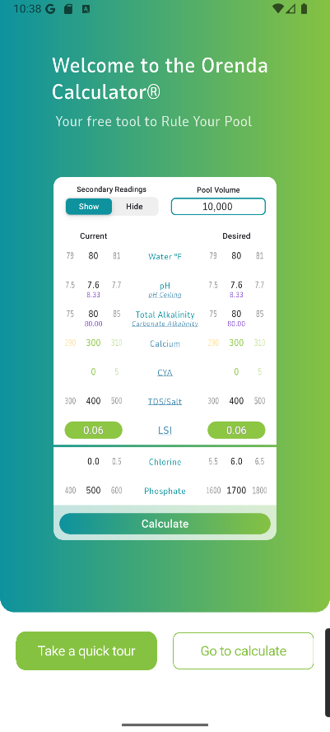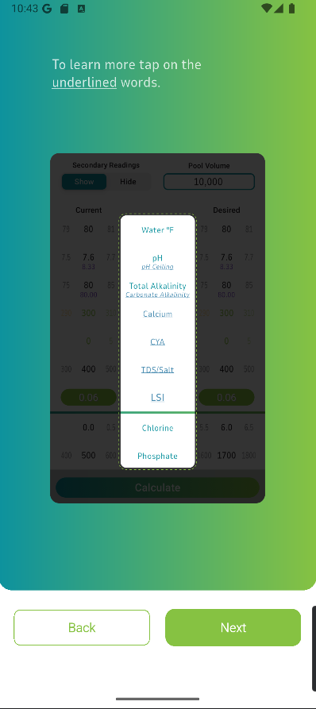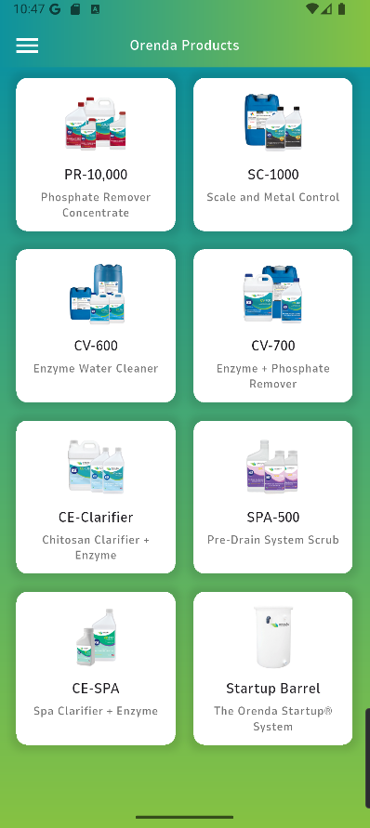

Figure 1.1 Figure 1.2 Figure 1.3

Features to Adapt:

Scientific Accuracy: As visible in Figure 1.1, the core of Orenda's value is its scientific rigor. This chemical calculator provides a highly detailed system that allows users to check their pool specifications against a well-tested system. We should adapt its focus on precise chemical calculations and correct water balance principles. SplashScreen's water chemistry calculator must be scientifically sound and highly reliable.

Educational Content: Orenda’s user support is high. When logging in to the application for the first time, users are introduced to how the chemical calculator works, Figure 1.2. In addition to this, there is also a dedicated panel for searchable educational content, under “Orenda Procedures”. User help and support is an important factor in the feasibility of our project. We should incorporate a feature that educates users on the "why" behind their maintenance tasks, building their knowledge and confidence over time.

Targeted Dosing: The system provides precise dosing recommendations based on pool volume and chemical readings. We can include this in our application and extend it to be more functional for other metrics.

Features to Avoid:

Exclusivity: The main issue we identified with Orenda is that it is extremely focused on the company’s specific chemical product line, not offering alternatives at better price ranges. Figure 1.3 illustrates products only offered by Orenda. This exclusivity is also extended through the professional-centric language that be complicated to understand. Our system should avoid brand exclusivity and use language that is accessible to the average pool owner.

Lack of Proactive Features: Orenda is a manual calculator that requires constant user input. While SplashScreen will adapt this model, we will extend it with our proposed proactive features such as load shedding alerts, municipality restriction check, and weather-based predictions.

Lack of Business Model: As mentioned previously, Orenda is solely built for the Orenda enterprise. This architecture lacks our proposed marketplace, where users can interact with business profiles, services and products.

Reference: Orenda. (n.d.). Orenda App. Retrieved from https://www.orendatech.com/app

Pool Chemical Calculator

Platform: Android, iOS
Description: Pool Chemical Calculator is a well-known hybrid system that serves both individual pool owners and small maintenance businesses. It provides a comprehensive set of tools for calculating chemical dosages, tracking multiple pools, and even planning service routes. The app is highly functional but can feel cluttered due to its broad range of features. It aims to be an all-in-one tool for pool management.

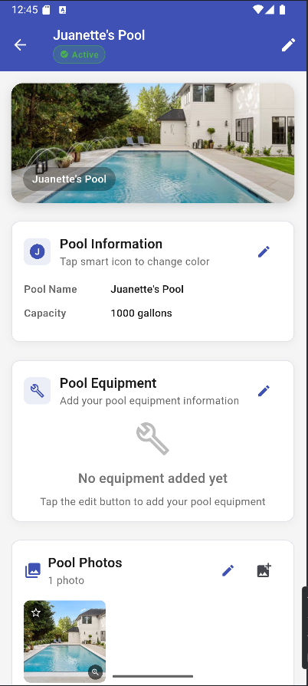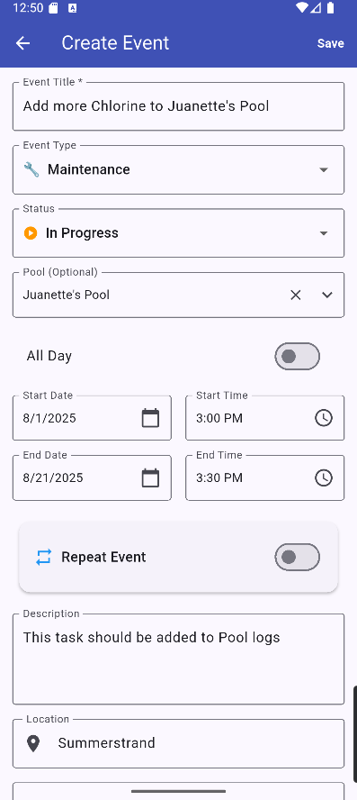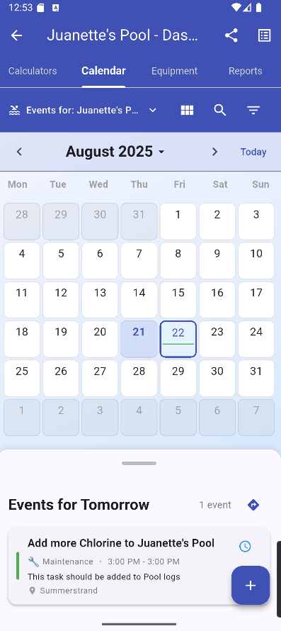
Figure 2.1 Figure 2.2 Figure 2.3

Features to Adapt:

Multi-Pool Management: The ability to add and manage multiple pools is crucial for both our pool individuals and service providers. Figure 2.1 showcases Pool Chemical Calculator’s multi-pool management system, equipped with tracking for different parameters. We will adapt this feature to allow users to track their home pool, a second property, or even a small portfolio of client pools for local service providers.

Task Management: The system has a robust task list and reminders through a built in Calendar system. Figure 2.2 demonstrates the procedure of creating an event also represented as tasks. Once complete, these are added to the respective pool’s calendar dashboard, Figure 2.3. We will incorporate a similar feature for scheduling and tracking maintenance tasks, extending our app’s maintenance capabilities.

Hybrid User Model: This app proves that a single platform can effectively serve both individuals and professionals. Pool management is universal for both individuals and businesses while there are unique features such as route tracking for pool location made solely for service providers. As SplashScreen incorporates both user types, adapting this approach by offering distinct but integrated user experiences for our B2C and B2B users will support our marketplace model.

Features to Avoid:

User Interface Clutter: The app's wide range of features can make the UI feel busy and overwhelming for a new user. We must avoid this by designing a clean interface that is easy to navigate.

Lack of Specialization: By trying to do everything, the Pool Chemical Calculator doesn't excel in a single area. We must avoid this by making our core features, such as chemical tracking, load shedding alerts, and marketplace integration highly polished.

Reference: Pool Chemical Calculator. (n.d.). Pool Chemical Calculator App. Retrieved from https://poolcalculator.com/

Pool Math

Platform: Web, Android, iOS
Description: This app, created by the highly respected Trouble-Free Pool (TFP) community, is considered the go-to app for DIY pool owners. It's an advanced and free-to-use chemical calculator that gives incredibly accurate dosing instructions based on the user's specific pool volume and readings. It's built on a very specific and popular methodology, which makes it a trusted source for millions of pool owners worldwide.

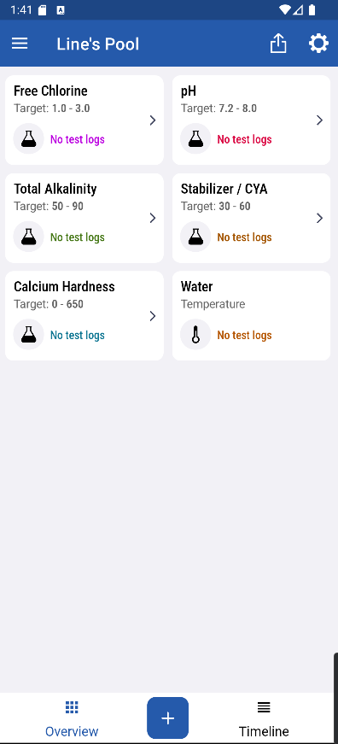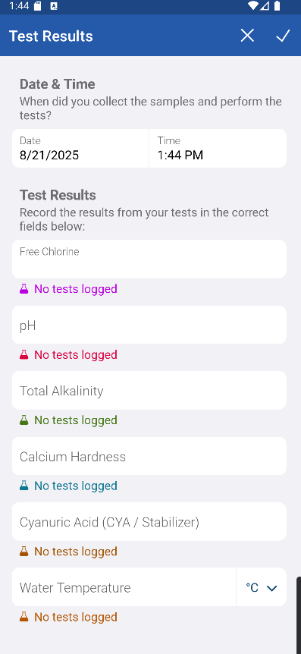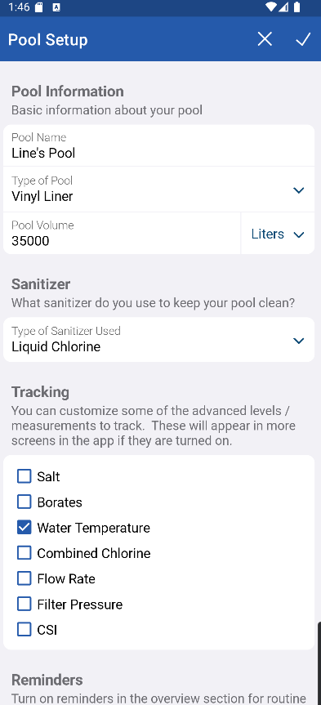
Figure 3.1 Figure 3.2 Figure 3.3

Features to Adapt:

Scientific Accuracy and Trust: The main feature we have identified from PoolMath is that accuracy builds trust. Its calculator is simple but flawless. Once again as stated in our analysis of Orenda, the core chemical calculation functionality of SplashScreen must be reliable to earn our app users' trust. All 3 Figures demonstrated the capabilities of PoolMath.

Simple, Focused UI: The app's interface isn't fancy, but it gets the job done without any distractions. Figure 3.1 shows us the simple central card stack for different calculations while Figure 3.2 is the test results in action. Evidently, this proves that while a modern UI is a requirement, a complex one isn’t. As The Ripple Effect, we strive to build a similarly intuitive and clean user experience.

Community Integration: While not built into the app itself, Pool Math's success is tied to the TFP online community. We identified this as a strong factor in our Software Development Life Cycle as a knowledgeable support base will drive the feasibility of this project.

Features to Avoid:

A Manual-Only System: Pool Math is a pure calculator. It doesn't offer any proactive features like push notifications, load shedding alerts, or weather-based predictions. SplashScreen shouldn’t share its passive nature but be an app that actively helps the user.

Lack of a Marketplace: PoolMath has no business model. It's simply a tool. Our app, by contrast, must solve the problem of finding local service providers and products. PoolMath's singular focus on DIY is a flaw from a business perspective, and SplashScreen’s hybrid model directly addresses this.

Reference: Pool Math. (n.d.). Pool Math App. Retrieved from https://poolmath.com/

1.5 The project plan
A project, or project management plan is a document that contains a project scope and objective. Typically, it will be represented as a Gannt chart to make it easy to convey information.
A project plan should answer these questions:
- What are we delivering?
- How will we deliver on time?
- Who is working on the project and in what role?
- What miles stones/goals are set for project?
We are creating a project plan to help us create the best solution for our application to provide a great experience for our clients. We are aiming to deliver a system that can capture data of amount of water a pool contains and its ph. levels to manage it chlorine levels. The different pool equipment to keep track of and maintain as well as being able to book and register clients and staff members for companies. Companies will be able to manage their employees’ schedules and plan for maintaining different clients’ schedules. We will also be including a weather app and app store? to keep track of pool care and replacement of existing equipment.
We will be slitting up parts of the project into sections between everyone and setting deadlines to allow for a smooth working schedule allowing for a smooth and quick progression of the project. Thus allowing for the project to be delivered on time.
We have slit the project between the 3 members working on it, Liné, Juanette and Tino, to allow everyone to do their part. All three of us will be working on the documentation and coding as well as giving our selves main roles to focus on. Liné will be focusing on the [insert role]. Juanette will be working on the [insert role]. Tino will be our main coder and proofreader.
The miles stones we have set is slit between 3 parts, part 1 all the documentation, part 2 building and programming of our application and part 3 the finishing touches as well as the presentation of our system. Part 1 will be divided between different documents to get everything ready for the implementation of the project. Such as the proposal, business case, system requirements, specifications and technical design and the implementation documentation. Part 2 to will be focusing on the backend, frontend and design of our application. Part 3 will focus on fixing and improving any problems or designs that don’t function properly as well as preparing everything for our presentation of our system.
Before you can start your project plan you need to understand (at a minimum) the following things:
- What does your client expect/need?
- The goals of the project
- What is the decision-making process of your client, and how will they approve and review the project work?
- Who is the sponsor?
- Who is the project manager?
- What other stakeholders are important?
As project manager you also need clarity from your client to know exactly what their expectations are. Sometimes this requires you to ask some hard questions to get a clear understanding.
Questions that may impact a project plan:
- How will you collect feedback?
- Who has the final sign-off?
- What is the project deadline?
- What is the availability of the project team?
- How often will the teams meet for feedback?
- Does your team have a history of successful projects?
- What can prevent the project from being a success?
- What tools and methods of communication will the team use?
Your project plan should include the following information (at the very minimum):
- Project and client name (make one up)
- Delivery date and version
- Milestones and deliverables
- Clear task durations with start and end dates (using a Gantt chart)
- Dependencies for tasks (i.e., should anything happen before this task can happen).
The Ripple Effect views the success of SplashScreen based on 2 factors: client satisfaction and team execution. As we complete weekly sprints, adapting an agile approach, specifically mirroring Scrum practices, we will be completing bi-weekly reviews with our client through sharing our current documentation and collecting responses from [Insert Client here] team. This will be achieved through Google Forms? We strive to complete the full project by 1st November 2025, hosting a team stand-up where we share weekly updates. Our project portfolio of successful projects currently includes:
CheckIT
Platform: Android
Description: A full-stack Android app using Java and SQLite that facilitates task management between instructors and students, with role-based access for admins, instructors, and students.
Project Link: https://github.com/Passion-Over-Pain/CheckIT

Download Link: https://github.com/Passion-Over-Pain/CheckIT/releases/download/v1.0/CheckIT.apk

Project Management Web App
Platform: Web
Description: As part of this project, we developed an IT Project Management web application designed to streamline the process of assigning and tracking tasks for a project team.
Project Link: https://github.com/Passion-Over-Pain/ProjectManagementApp-Assignment

During our previous projects, a couple of issues we identified that inhibited the success of our workflow as well as some we have experienced in the current execution of SplashScreen are outlined below:

- Limited Time: The time constraint for both of our previous projects has prevented us from completing these project flows at our best ability. With SplashScreen, we are mitigating this by starting our software iterations earlier in the SDLC.
- Limited Resources: As this project is currently unfunded, we are limited to a catalogue of digital resources we can use. What we have recently encountered during our project management is that ClickUp, our previous project management tool has limited our access to the Gantt Chart view, something crucial for our workflow. We have decided to migrate to using ZenHub, a free open-source GitHub integration for project management.

[After other sections]
It is evident that the project plan is a crucial section in developing SplashScreen thus we have decided to map out our entire workflow on ZenHub using the timeline feature, Figure 4.1. This is similar to other Gantt chart features present by project management tools such as ClickUp and Wrike but aligns with our project resources.
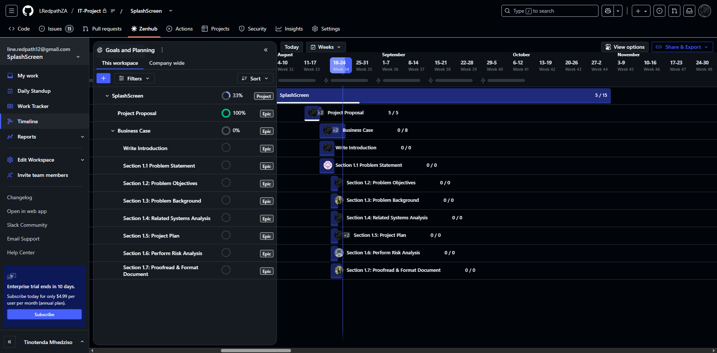

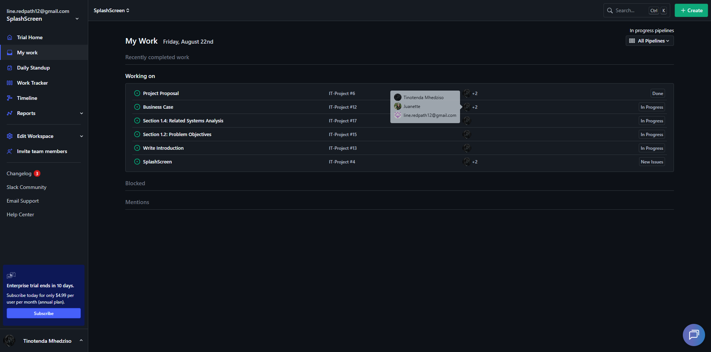

Our project comprises of the following sections:
Project Proposal, Business Case, System Requirements, Specifications and Technical Design, Implementation, Final Submission, System Presentation. We have organized our Bi-weekly sprints based on each section submission. Each section is then segmented into feasible tasks. Our current sprint, the Business Case is broken up into a couple of tasks such as Write Introduction, Section 1.1 Problem Statement etc. where each task can have subtasks represented by the number to completion, 5/15 for example. As viewed in Figure 4.2, each project member is assigned a set of tasks to complete, with a respective start and end date, for a respective sprint and after each sprint, each project member presents their completed processes, challenges and insights.
As The Ripple Effect, our 3 members are often busy with their personal life commitments. That’s why we have chosen this agile based workflow that allows us to operate in a flexible manner while not hindering productivity.
1.6 Risk Analysis

A risk can be defined as an unexpected event or condition, which can impact negatively on the entire project. Some will argue that the event or condition can also affect the project in a positive way.
There are many models, which are used to identify different risks. But we will not go into specific ones here. In general, we can say that to categorise risks can help in the process. You will quickly discover that you need to limit yourself regarding risks during a brainstorming activity. Otherwise, the list of events and conditions can become very long. You need to assess how likely it is that the particular event occurs. For instance: The entire project could be ruined if a woman in labour runs across a road and a driver has to swerve to avoid her. The driver crashes into a bus and loses a wheel, which rolls across the road, pulls along a bag of dynamite, which was about to be used. The dynamite then explodes next to a lamppost, which shoots, like a rocket, through the window of the project teams office. The rocket hits the project leader in the head and the project leader, by mistake, deletes all the code, which has been written. The rocket continues through the office and finally lands on a shelf filled with super magnets, which then fall onto the server, which contains all the backups and removes them all. But how likely is this?
Once you have identified the risks, you need to decide how you will handle those risks. It is a good idea to divide the risks into four main categories:
Acceptable risks: We decide that the risk is very unlikely, or possibly, that the costs if that event happens, are lower than the expenses which are necessary to prevent the event from taking place.
Avoidable risks: We take action which ensures that we prevent a certain event or condition. We might create backups of all the code and store it in two separate locations. Then we avoid the risk of losing anything,
Minimizable risks: We take steps to ensure that the likelihood of something happening is less. We can create a bonus structure to make sure that people do not leave.
Transferable risks: This means that we transfer the risk to someone else. For example, we might send part of the work to another company. Then it is the other company, which needs to assume the risk. Once we have categorised all the risks, we need to decide exactly what needs to be done, if something should be done. We need to prepare ourselves as best we can so that any potential events have as little impact on the project as possible. We can, of course, have free fruit available at work and encourage everyone to exercise regularly. But someone will get sick in any case and then it is great to know how we handle that. Who is going to take over the sick person's work? When is it necessary for someone to step in? Should the person step in be someone in the team or someone from outside the team? In the case of the latter, where should the person be brought in from? How much will this cost?
Identify (at least) 4 risks to your project. If you have time, add more, since the more you are able to identify at the start, the better you can plan for things to go wrong (and they usually do). For each risk, state which type of risk it is and how you will treat/handle the risk.

1.7 References

Department of Water and Sanitation. (2023). National water resources and restrictions overview. Government of South Africa. https://www.dws.gov.za
Centers for Disease Control and Prevention. (2024). Operating and managing public pools, hot tubs and splash pads. https://www.cdc.gov/healthy-swimming/toolkit/operating-public-pools-hot-tubs-and-splash-pads.html cdc.gov
Department of Water and Sanitation (South Africa). (2023). National State of Water Report 2023. https://www.dws.gov.za/Projects/National%20State%20of%20Water%20Report/Documents/National%20State%20of%20Water%20Report%202023_FinalVer3.0.pdf Department of Water and Sanitation
Department of Water and Sanitation (South Africa). (2022). Clear Rivers campaign booklet. https://www.dws.gov.za/campaigns/Clear-River2022/Documents/Clear%20Rivers_Booklet_A4%202022.pdf Department of Water and Sanitation
Du Plessis, J., & Jacobs, H. E. (2015). Mitigating the impact of swimming pools on domestic water demand. Water SA, 41(2), 238–244. https://www.scielo.org.za/scielo.php?script=sci_arttext&pid=S1816-79502015000200010 SciELO
Econsultancy. (2022). HTH South African swimming pool care campaign case study. https://econsultancy.com/case-studies/view/hth-south-african-swimming/ Econsultancy
Musango, J. K., & Peter, C. (2012). Swimming pools and intra-city climates: Influences on residential water consumption in Cape Town. Water SA, 38(1), 91–98. https://www.scielo.org.za/scielo.php?script=sci_arttext&pid=S1816-79502012000100016 SciELO
Pool-Cover South Africa. (2025). The costs of filling a swimming pool. https://www.pool-cover.co.za/the-costs-of-filling-a-swimming-pool/ pool-cover.co.za
South African Government. (n.d.). Geography and climate. https://www.gov.za/about-sa/geography-and-climate Government of South Africa
Wuppertal Institute for Climate, Environment and Energy. (2015). Energy efficient swimming pool pumps (South Africa). https://bigee.net/media/filer_public/2015/07/23/bigee_south_africa_poolpumps_20150723.pdf bigee.net
World Bank Climate Change Knowledge Portal. (n.d.). South Africa – climatology. https://climateknowledgeportal.worldbank.org/country/south-africa/climate-data-historical climateknowledgeportal.worldbank.org
Baracuda (Zodiac South Africa). (2023). 6 tips for maintaining pool equipment during load shedding. https://baracuda.co.za/blog/pool-equipment-loadshedding-tips/ Baracuda
City of Cape Town. (2019). Water restrictions summary table – comparison of all levels. https://resource.capetown.gov.za/documentcentre/Documents/Forms%2C%20notices%2C%20tariffs%20and%20lists/Water%20restrictions%20summary%20table%20-%20Comparison%20of%20all%20levels.pdf resource.capetown.gov.za
The Guardian. (2023, April 10). Swimming pools of the rich driving city water crises, study says. https://www.theguardian.com/environment/2023/apr/10/swimming-pools-rich-driving-city-water-crises The Guardian
The Washington Post. (2023, April 11). Wealthy residents’ pools and gardens are driving water crises. https://www.washingtonpost.com/climate-environment/2023/04/11/water-crisis-swimming-pool-cape-town/ The Washington Post
National Poly Industries. (2017). How much water do swimming pools lose each day? https://nationalpolyindustries.com.au/wp-content/uploads/2018/03/how-much-water-do-swimming-pools-lose-each-day.pdf National Poly Industries

